Modifying or Cancelling Exams in MinerAccess
Step1: Log into MinerAccess using your S&T username and password
Step 2: Access the Dashboard
- After logging in, you’ll land on the My Dashboard
- Look for the Accommodations tab on the left side of the screen, and click on the Alternative Testing button.

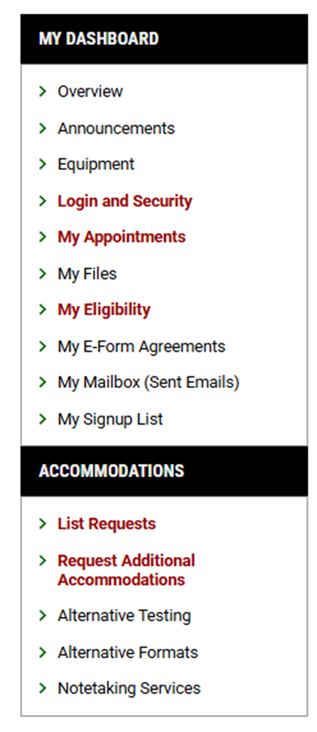

Step 3: Under Upcoming Exams Scheduled, you will find the exam that you would like to modify or cancel. Click on view.
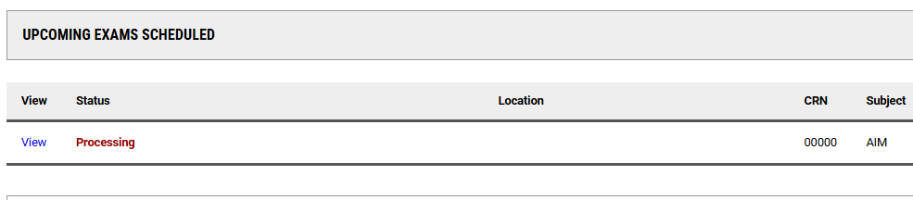

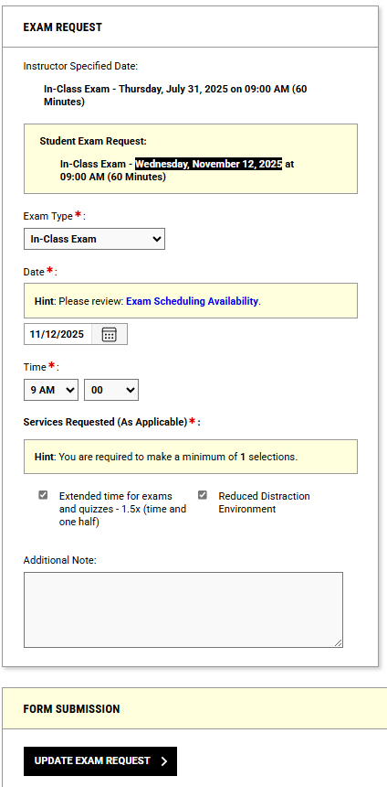
Step 4: For Modification of Exam, fill out the Exam Request portion you would like to modify and click on Update Exam Request.

OR
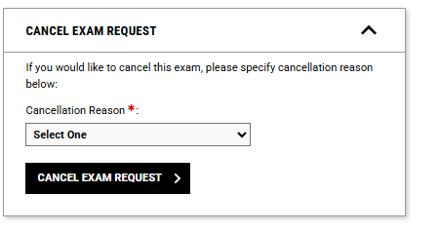
For Cancellation of Exam, fill out the Cancel Exam Request box and click on Cancel Exam Request.

